# 1st Deployment – through local machine command

## Partitions

See some latest partitions have data

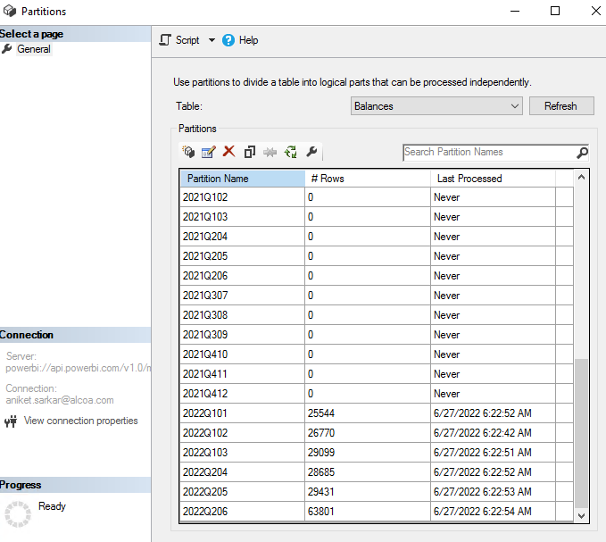

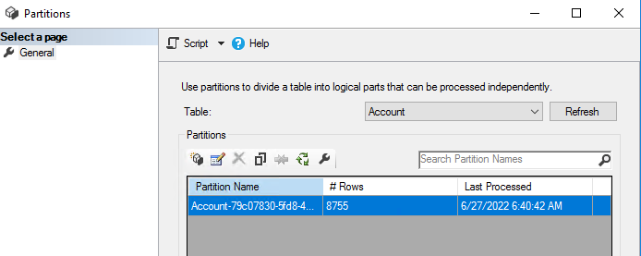

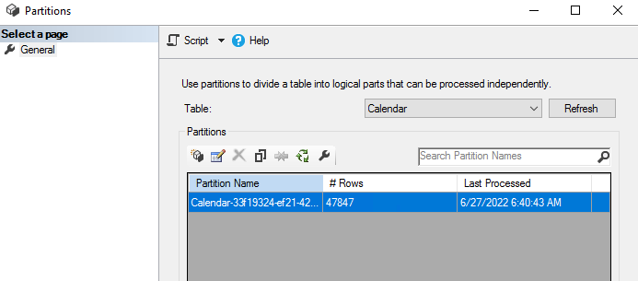

## Detail Row Expression

Sample code of the model after 1st deployment

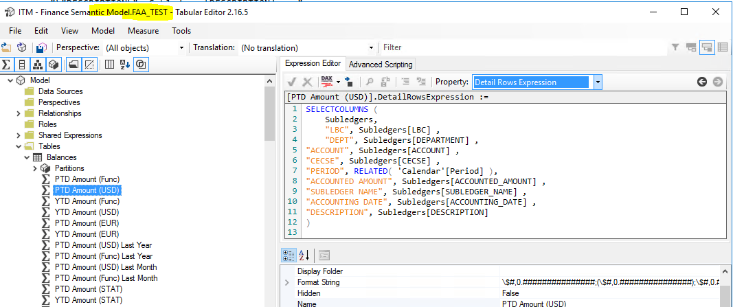

# 2nd Deployment - through local machine command

## Change

manually added another line (highlighted)

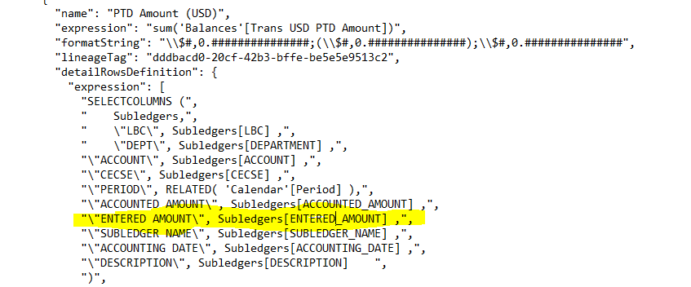

## Partitions

See all partitions retained the data after 2nd deployment

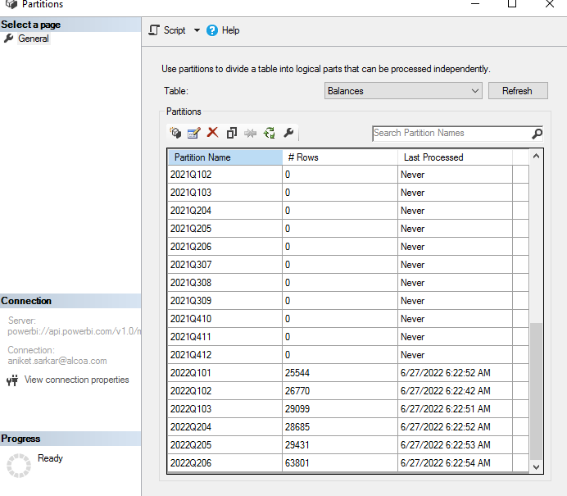

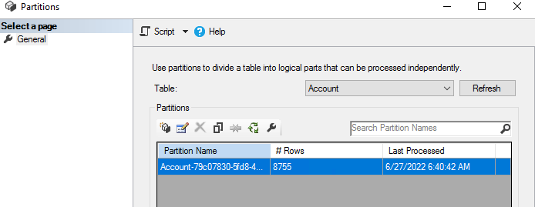

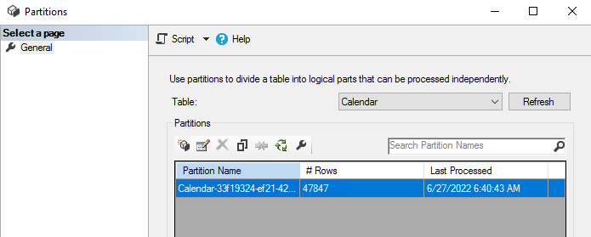

## Detail Row Expression

See the added line is reflected after the 2nd (incremental) deployment

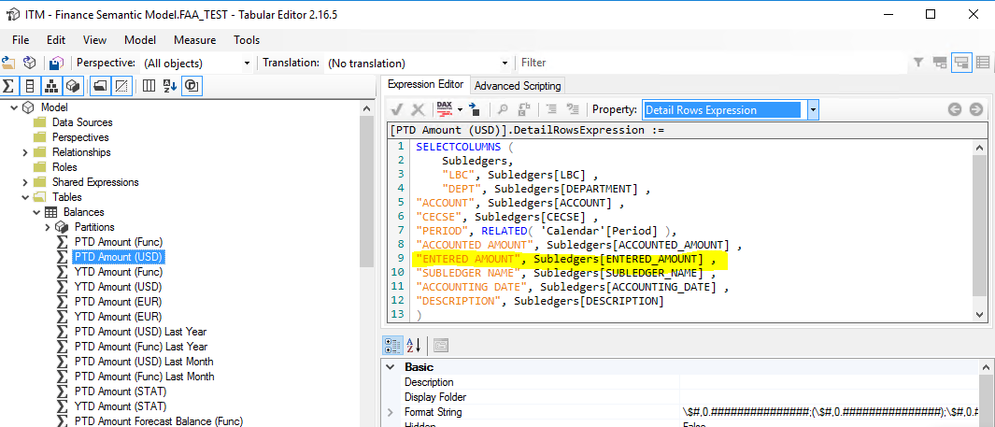

# Issue in DevOps

